What is Tailwind CSS?
- Tailwind CSS can be used to style websites in the fastest and easiest way.
- Tailwind CSS is basically a utility-first CSS framework for rapidly building custom user interfaces.
- It is a highly customizable, low-level CSS framework that gives you all of the building blocks you need to build bespoke(specially made for a particular person, organization, or purpose) designs without any annoying opinionated styles you have to fight to override.
- In Tailwind, you simply bring tiny components together to construct a user interface that is unique.
- Tailwind CSS was created in 2017 by Adam Wathan and Steve Schoger.

“Utility-first CSS framework packed with classes to build any design.”

- Unlike Bootstrap, Tailwind CSS doesn’t come with prebuilt classes like dropdown-menu and dropdown-item. (But there is an additional, paid UI kit offered by Tailwind’s creators, since it’s not part of the core offering)
- Instead, it’s up to you to design and build your own components and design. They simply provide you with the tools to do it quickly and easily.
- Tailwind CSS comes with some extensions in VS Code (Tailwind CSS IntelliSense) that helps you autocomplete suggestions and provide class definitions without needing to leave your editor.
- Tailwind CSS also makes responsive designs easy as they handle all the media queries for you, you just need to use the breakpoint(xs, sm, md, lg, xl) you want to target in front of the class you’re using.

Instead of writing CSS yourself and worrying about things like class naming conventions, Tailwind CSS handles it all for you, and you just need to use the classes directly on the elements you wish to style.

- The utility classes like p-4, text-center, and rounded-full. These are all abstractions of traditional CSS properties: padding, text-align, and border-radius.

Now let’s take a look at a basic example of Tailwind CSS:

<div class="bg-gray-200 p-4">

<h2 class="font-bold text-lg">Lizard</h2>

</div>

This shows an example application of different Tailwind CSS utility classes, such as:

• bg-gray-200 for the background color

• p-4 for padding

• font-bold and text-lg for text styling

Why Tailwind CSS?
- The faster UI building process.
- If having a unique design is vital to the project or your brand identity, then having the freedom to build completely custom might be the best choice, and that's what Tailwind CSS offers you.
- This means you need to design and build all your components from scratch.
- Tailwind’s utility-first approach with highly customizable classes allows for greater styling flexibility suited to projects that need heavy customization and branding.
As we know there are many CSS frameworks but people always choose the fast and easy framework to learn and use in the project. Tailwind has come with inbuilt a lot of features and styles for users to choose from and is also used to reduce the tendency of writing CSS code and create a beautiful custom UI. It will help you to overcome the complicated task. Tailwind CSS creates small utilities with a defined set of options enabling easy integration of existing classes directly into the HTML code.

When to Use Tailwind CSS
- Tailwind CSS is best used to speed up the development process by writing less code.
- It comes with a design system that helps maintain consistency across various design requirements like padding, spacing, and so forth; with this, you do not have to worry about creating your design systems.
- You can also use Tailwind CSS if you are looking to use a framework that is easily configurable because it does not force you to use components (navigation bars, buttons, forms, and so forth) in the same way all the time; you get to choose what your components should look like.
- But you should never use Tailwind if you have not learned and practiced CSS.
Pros and Cons of Tailwind CSS
Here are some of the advantages of using Tailwind CSS:
- Faster development process
- Helps you practice your CSS more as the utilities are similar
- All utilities and components are easily customizable
- The overall file size for production is usually small
- Easy to learn if you already know CSS
- Good documentation for learning
Some of the disadvantages of using Tailwind CSS include:
- Your markup might look disorganized for large projects because all the styles are in the HTML files.
- It isn’t easy to learn if you don’t understand CSS well.
- You are forced to build everything from scratch, including your input elements. When you install Tailwind CSS, it removes all default CSS styles.
- Tailwind CSS is not the best option if you are looking to minimize time spent developing your website’s frontend and mainly focusing on the backend logic.

Understanding of Various Methods to use tailwind CSS (Installation)

> Tailwind CLI

> Framework Guides

> Play CDN

Using Tailwind via CDN
- Use the CDN to try Tailwind right in the browser without any build step.
- Add the CDN script tag to the <head> of your HTML file, and start using Tailwind’s utility classes to style your content.
<script src="https://cdn.tailwindcss.com"></script>

Note: There are some limitations when CDN is used. Some of them are:
- Customize Tailwind’s default theme can’t be used
- Directives like @apply, @variants, etc can’t be used
- Can’t install third-party plugins

Find quickly all the class names and CSS properties with below cheat sheets.
https://nerdcave.com/tailwind-cheat-sheet
https://tailwindcomponents.com/cheatsheet/

Spacing
Padding
Utilities for controlling an element's padding.
Add padding to a single side
- Control the padding on one side of an element using the p{t|r|b|l}-{size} utilities.
- For example,
  - pt-6 would add 1.5rem of padding to the top of an element,
  - pr-4 would add 1rem of padding to the right of an element,
  - pb-8 would add 2rem of padding to the bottom of an element,
  - pl-2 would add 0.5rem of padding to the left of an element.
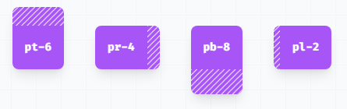
Add horizontal padding
Control the horizontal padding of an element using the px-{size} utilities.

Add Vertical padding
Control the vertical padding of an element using the py-{size} utilities.
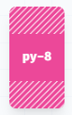
Add padding to all sides
Control the padding on all sides of an element using the p-{size} utilities.
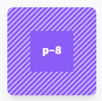
Margin
Utilities for controlling an element's margin.
Add margin to a single side
- Control the margin on one side of an element using the m{t|r|b|l}-{size} utilities.
  - mt-6 would add 1.5rem of margin to the top of an element,
  - mr-4 would add 1rem of margin to the right of an element,
  - mb-8 would add 2rem of margin to the bottom of an element,
  - ml-2 would add 0.5rem of margin to the left of an element.
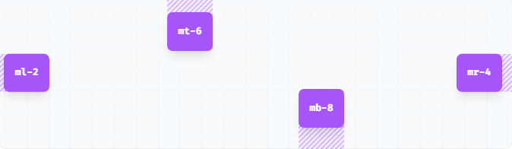
Add horizontal margin
Control the horizontal margin of an element using the mx-{size} utilities.

Add vertical margin
Control the vertical margin of an element using the my-{size} utilities.
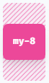
Add margin to all sides
Control the margin on all sides of an element using the m-{size} utilities.

Class | CSS Property value | Pixel Value
.m-0 | margin: 0px;
.m-1 | margin: 0.25rem; | 4px
.m-2 | margin: 0.5rem; | 8px
.m-3 | margin: 0.75rem; | 12px
.m-4 | margin: 1rem; | 16px
.m-5 | margin: 1.25rem; | 20px
.m-6 | margin: 1.5rem; | 24px
.m-7 | margin: 1.75rem; | 28px
.m-8 | margin: 2rem; | 32px
.m-9 | margin: 2.25rem; | 36px
.m-10 | margin: 2.5rem; | 40px
.m-11 | margin: 2.75rem; | 44px
.m-12 | margin: 3rem; | 48px
.m-14 | margin: 3.5rem; | 56px
.m-16 | margin: 4rem; | 64px
.m-20 | margin: 5rem; | 80px
.m-24 | margin: 6rem; | 96px
.m-28 | margin: 7rem; | 112px
.m-32 | margin: 8rem; | 128px
.m-36 | margin: 9rem; | 144px
.m-40 | margin: 10rem; | 160px
.m-44 | margin: 11rem; | 176px
.m-48 | margin: 12rem; | 192px
.m-52 | margin: 13rem; | 208px
.m-56 | margin: 14rem; | 224px
.m-60 | margin: 15rem; | 240px
.m-64 | margin: 16rem; | 256px
.m-72 | margin: 18rem; | 288px
.m-80 | margin: 20rem; | 320px
.m-96 | margin: 24rem; | 384px
.m-auto | margin: auto;
.m-px | margin: 1px;
.m-0.5 | margin: 0.125rem; | 2px
.m-1.5 | margin: 0.375rem; | 6px
.m-2.5 | margin: 0.625rem; | 10px
.m-3.5 | margin: 0.875rem; | 14px
Use same values for the specific sides like right(mr), left(ml), top(mt), bottom(mb) and also same for the padding.

Sizing
In Tailwind, the height and width properties are denoted by the .h-{number} and .w-{number} classes.
Height
Fixed heights
Use h-{number} or h-px to set an element to a fixed height.
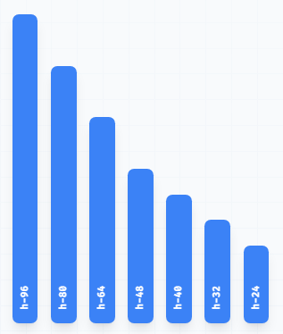
h-0 | height: 0px;
h-px | height: 1px;
h-0.5 | height: 0.125rem; /* 2px */
h-1 | height: 0.25rem; /* 4px */
h-1.5 | height: 0.375rem; /* 6px */
h-2 | height: 0.5rem; /* 8px */
h-2.5 | height: 0.625rem; /* 10px */
h-3 | height: 0.75rem; /* 12px */
h-3.5 | height: 0.875rem; /* 14px */
h-4 | height: 1rem; /* 16px */
h-5 | height: 1.25rem; /* 20px */
h-6 | height: 1.5rem; /* 24px */
h-7 | height: 1.75rem; /* 28px */
h-8 | height: 2rem; /* 32px */
h-9 | height: 2.25rem; /* 36px */
h-10 | height: 2.5rem; /* 40px */
h-11 | height: 2.75rem; /* 44px */
h-12 | height: 3rem; /* 48px */
h-14 | height: 3.5rem; /* 56px */
h-16 | height: 4rem; /* 64px */
h-20 | height: 5rem; /* 80px */
h-24 | height: 6rem; /* 96px */
h-28 | height: 7rem; /* 112px */
h-32 | height: 8rem; /* 128px */
h-36 | height: 9rem; /* 144px */
h-40 | height: 10rem; /* 160px */
h-44 | height: 11rem; /* 176px */
h-48 | height: 12rem; /* 192px */
h-52 | height: 13rem; /* 208px */
h-56 | height: 14rem; /* 224px */
h-60 | height: 15rem; /* 240px */
h-64 | height: 16rem; /* 256px */
h-72 | height: 18rem; /* 288px */
h-80 | height: 20rem; /* 320px */
h-96 | height: 24rem; /* 384px */
h-auto | height: auto;
h-1/2 | height: 50%;
h-1/3 | height: 33.333333%;
h-2/3 | height: 66.666667%;
h-1/4 | height: 25%;
h-2/4 | height: 50%;
h-3/4 | height: 75%;
h-1/5 | height: 20%;
h-2/5 | height: 40%;
h-3/5 | height: 60%;
h-4/5 | height: 80%;
h-1/6 | height: 16.666667%;
h-2/6 | height: 33.333333%;
h-3/6 | height: 50%;
h-4/6 | height: 66.666667%;
h-5/6 | height: 83.333333%;
h-full | height: 100%;
h-screen | height: 100vh;

Full height
Use h-full to set an element’s height to 100% of its parent, as long as the parent has a defined height.
Viewport height
Use h-screen to make an element span the entire height of the viewport.

Width
Utilities for setting the width of an element.
Fixed widths
Use w-{number} or w-px to set an element to a fixed width.
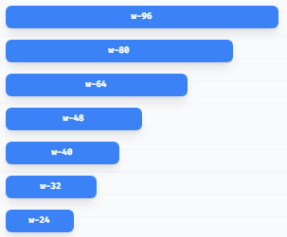
w-0 | width: 0px;
w-px | width: 1px;
w-0.5 | width: 0.125rem; /* 2px */
w-1 | width: 0.25rem; /* 4px */
w-1.5 | width: 0.375rem; /* 6px */
w-2 | width: 0.5rem; /* 8px */
w-2.5 | width: 0.625rem; /* 10px */
w-3 | width: 0.75rem; /* 12px */
w-3.5 | width: 0.875rem; /* 14px */
w-4 | width: 1rem; /* 16px */
w-5 | width: 1.25rem; /* 20px */
w-6 | width: 1.5rem; /* 24px */
w-7 | width: 1.75rem; /* 28px */
w-8 | width: 2rem; /* 32px */
w-9 | width: 2.25rem; /* 36px */
w-10 | width: 2.5rem; /* 40px */
w-11 | width: 2.75rem; /* 44px */
w-12 | width: 3rem; /* 48px */
w-14 | width: 3.5rem; /* 56px */
w-16 | width: 4rem; /* 64px */
w-20 | width: 5rem; /* 80px */
w-24 | width: 6rem; /* 96px */
w-28 | width: 7rem; /* 112px */
w-32 | width: 8rem; /* 128px */
w-36 | width: 9rem; /* 144px */
w-40 | width: 10rem; /* 160px */
w-44 | width: 11rem; /* 176px */
w-48 | width: 12rem; /* 192px */
w-52 | width: 13rem; /* 208px */
w-56 | width: 14rem; /* 224px */
w-60 | width: 15rem; /* 240px */
w-64 | width: 16rem; /* 256px */
w-72 | width: 18rem; /* 288px */
w-80 | width: 20rem; /* 320px */
w-96 | width: 24rem; /* 384px */
w-auto | width: auto;
w-1/2 | width: 50%;
w-1/3 | width: 33.333333%;
w-2/3 | width: 66.666667%;
w-1/4 | width: 25%;
w-2/4 | width: 50%;
w-3/4 | width: 75%;
w-1/5 | width: 20%;
w-2/5 | width: 40%;
w-3/5 | width: 60%;
w-4/5 | width: 80%;
w-1/6 | width: 16.666667%;
w-2/6 | width: 33.333333%;
w-3/6 | width: 50%;
w-4/6 | width: 66.666667%;
w-5/6 | width: 83.333333%;
w-1/12 | width: 8.333333%;
w-2/12 | width: 16.666667%;
w-3/12 | width: 25%;
w-4/12 | width: 33.333333%;
w-5/12 | width: 41.666667%;
w-6/12 | width: 50%;
w-7/12 | width: 58.333333%;
w-8/12 | width: 66.666667%;
w-9/12 | width: 75%;
w-10/12 | width: 83.333333%;
w-11/12 | width: 91.666667%;
w-full | width: 100%;
w-screen | width: 100vw;

Full Width
Use w-full to set an element’s width to 100%.

Viewport width
Use w-screen to make an element span the entire width of the viewport.

Setting the minimum width
Set the minimum width of an element using min-w-* utilities.

Setting the maximum width
Set the maximum width of an element using the max-w-* utilities.

Setting the minimum height
Set the minimum height of an element using min-h-* utilities.

Setting the maximum height
Set the maximum height of an element using max-h-* utilities.

* values can be 0, px, 0.5, 1, 1.5, 2, 2.5, 3, 3.5, 4, 5, 6, 7, 8, 9, 10, 11, 12, 14, 16, 20, 24, 28, 32, 36, 40, 44, 48, 52, 56, 60, 64, 72, 80, 96 etc

Typography
Text color
text-inherit | text-current | text-transparent | text-black | text-white | text-slate-50
text-slate-100 | text-slate-200 | text-slate-300 | text-slate-400 | text-slate-500 | text-slate-600
text-slate-700 | text-slate-800 | text-slate-900 | text-slate-950 | text-gray-50 | text-gray-100
text-gray-200 | text-gray-300 | text-gray-400 | text-gray-500 | text-gray-600 | text-gray-700
text-gray-800 | text-gray-900 | text-gray-950 | text-zinc-50 | text-zinc-100 | text-zinc-200
text-zinc-300 | text-zinc-400 | text-zinc-500 | text-zinc-600 | text-zinc-700 | text-zinc-800
text-zinc-900 | text-zinc-950 | text-neutral-50 | text-neutral-100 | text-neutral-200 | text-neutral-300
text-neutral-400 | text-neutral-500 | text-neutral-600 | text-neutral-700 | text-neutral-800 | text-neutral-900
text-neutral-950 | text-stone-50 | text-stone-100 | text-stone-200 | text-stone-300 | text-stone-400
text-stone-500 | text-stone-600 | text-stone-700 | text-stone-800 | text-stone-900 | text-stone-950
text-red-50 | text-red-100 | text-red-200 | text-red-300 | text-red-400 | text-red-500
text-red-600 | text-red-700 | text-red-800 | text-red-900 | text-red-950 | text-orange-50
text-orange-100 | text-orange-200 | text-orange-300 | text-orange-400 | text-orange-500 | text-orange-600
text-orange-700 | text-orange-800 | text-orange-900 | text-orange-950 | text-amber-50 | text-amber-100
text-amber-200 | text-amber-300 | text-amber-400 | text-amber-500 | text-amber-600 | text-amber-700
text-amber-800 | text-amber-900 | text-amber-950 | text-yellow-50 | text-yellow-100 | text-yellow-200
text-yellow-300 | text-yellow-400 | text-yellow-500 | text-yellow-600 | text-yellow-700 | text-yellow-800
text-yellow-900 | text-yellow-950 | text-lime-50 | text-lime-100 | text-lime-200 | text-lime-300
text-lime-400 | text-lime-500 | text-lime-600 | text-lime-700 | text-lime-800 | text-lime-900
text-lime-950 | text-green-50 | text-green-100 | text-green-200 | text-green-300 | text-green-400
text-green-500 | text-green-600 | text-green-700 | text-green-800 | text-green-900 | text-green-950
text-emerald-50 | text-emerald-100 | text-emerald-200 | text-emerald-300 | text-emerald-400 | text-emerald-500
text-emerald-600 | text-emerald-700 | text-emerald-800 | text-emerald-900 | text-emerald-950 | text-teal-50
text-teal-100 | text-teal-200 | text-teal-300 | text-teal-400 | text-teal-500 | text-teal-600
text-teal-700 | text-teal-800 | text-teal-900 | text-teal-950 | text-cyan-50 | text-cyan-100
text-cyan-200 | text-cyan-300 | text-cyan-400 | text-cyan-500 | text-cyan-600 | text-cyan-700
text-cyan-800 | text-cyan-900 | text-cyan-950 | text-sky-50 | text-sky-100 | text-sky-200
text-sky-300 | text-sky-400 | text-sky-500 | text-sky-600 | text-sky-700 | text-sky-800
text-sky-900 | text-sky-950 | text-blue-50 | text-blue-100 | text-blue-200 | text-blue-300
text-blue-400 | text-blue-500 | text-blue-600 | text-blue-700 | text-blue-800 | text-blue-900
text-blue-950 | text-indigo-50 | text-indigo-100 | text-indigo-200 | text-indigo-300 | text-indigo-400
text-indigo-500 | text-indigo-600 | text-indigo-700 | text-indigo-800 | text-indigo-900 | text-indigo-950
text-violet-50 | text-violet-100 | text-violet-200 | text-violet-300 | text-violet-400 | text-violet-500
text-violet-600 | text-violet-700 | text-violet-800 | text-violet-900 | text-violet-950 | text-purple-50
text-purple-100 | text-purple-200 | text-purple-300 | text-purple-400 | text-purple-500 | text-purple-600
text-purple-700 | text-purple-800 | text-purple-900 | text-purple-950 | text-fuchsia-50 | text-fuchsia-100
text-fuchsia-200 | text-fuchsia-300 | text-fuchsia-400 | text-fuchsia-500 | text-fuchsia-600 | text-fuchsia-700
text-fuchsia-800 | text-fuchsia-900 | text-fuchsia-950 | text-pink-50 | text-pink-100 | text-pink-200
text-pink-300 | text-pink-400 | text-pink-500 | text-pink-600 | text-pink-700 | text-pink-800
text-pink-900 | text-pink-950 | text-rose-50 | text-rose-100 | text-rose-200 | text-rose-300
text-rose-400 | text-rose-500 | text-rose-600 | text-rose-700 | text-rose-800 | text-rose-900
text-rose-950

Note: The color’s values can be changeable according to your need from 50-950.

Sample example of colors
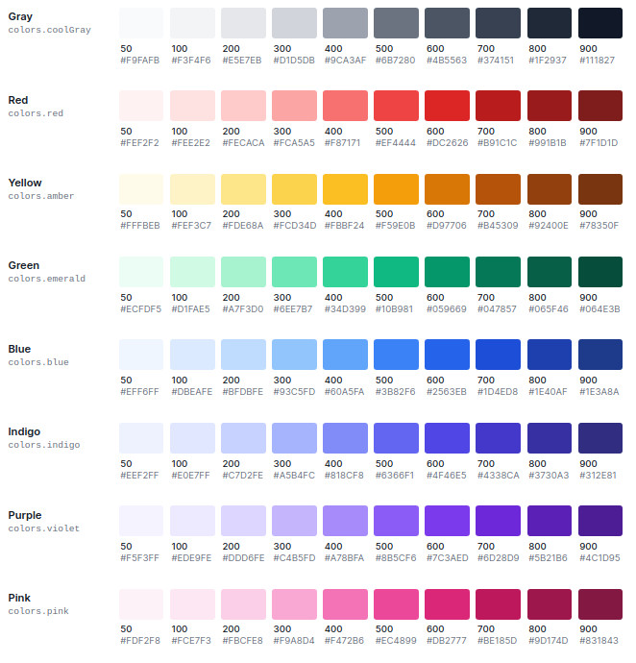

Text opacity
Control the opacity of an element’s placeholder color using the text-opacity-{amount} utilities.
Note: The number of the opacity can be changeable from 0 to 100 with the span of 5.
Example:
<p class="text-red-800 p-2 text-3xl">Tailwind Tutorial</p>
<p class="text-red-800 text-opacity-75 p-2 text-3xl">Tailwind Tutorial</p>
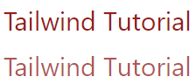

Font family
Font family classes:
- font-sans
- font-serif
- font-mono
font-sans | font-family: system-ui, -apple-system, BlinkMacSystemFont, "Segoe UI", Roboto, "Helvetica Neue", Arial, "Noto Sans", sans-serif, "Apple Color Emoji", "Segoe UI Emoji", "Segoe UI Symbol", "Noto Color Emoji";
font-serif | font-family: Georgia, Cambria, "Times New Roman", Times, serif;
font-mono | font-family: Menlo, Monaco, Consolas, "Liberation Mono", "Courier New", monospace;

Example:
<p class="text-red-800 p-2 text-3xl font-sans">Font Sans</p>
<p class="text-red-800 p-2 text-3xl font-serif">Font Serif</p>
<p class="text-red-800 p-2 text-3xl font-mono">Font Mono</p>

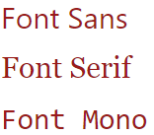
Font size
Font size classes:
text-xs | This class defines the text size as extra small.
text-sm | This class defines the text size as small.
text-base | This class defines the text size as base size.
text-lg | This class defines the text size as large.
text-xl | This class defines the text size as extra-large.
text-2xl | This class defines the text size as 2 times extra-large.
text-3xl | This class defines the text size as 3 times extra-large.
text-4xl | This class defines the text size as 4 times extra-large.
text-5xl | This class defines the text size as 5 times extra-large.
text-6xl | This class defines the text size as 6 times extra-large.
text-7xl | This class defines the text size as 7 times extra-large.
text-8xl | This class defines the text size as 8 times extra-large.
text-9xl | This class defines the text size as 9 times extra-large.
Note: Change the size in the component with the required size mentioned above.

Example:
<p class="text-red-800 p-2 text-xs">XS</p>
<p class="text-red-800 p-2 text-sm">SM</p>
<p class="text-red-800 p-2 text-base">BASE</p>
<p class="text-red-800 p-2 text-lg">LG</p>
<p class="text-red-800 p-2 text-xl">XL</p>
<p class="text-red-800 p-2 text-5xl">5XL</p>
<p class="text-red-800 p-2 text-9xl">9XL</p>
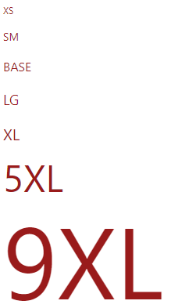

Font style
Font Style classes:
- italic
- non-italic
italic | This class is used to set the font style as italic.
non-italic | This is basically the default font, which is used to reset italic text at different breakpoints.
Example:
<p class="text-red-800 p-2 text-5xl italic">Italic</p>
<p class="text-red-800 p-2 text-5xl non-italic">Non Italic</p>
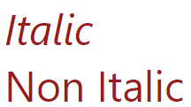
Font weight
Font weight classes:
font-thin | This class sets the font-weight to 100.
font-extralight | This class sets the font-weight to 200.
font-light | This class sets the font-weight to 300.
font-normal | This class sets the font-weight to 400.
font-medium | This class sets the font-weight to 500.
font-semibold | This class sets the font-weight to 600.
font-bold | This class sets the font-weight to 700.
font-extrabold | This class sets the font-weight to 800.
font-black | This class sets the font-weight to 900.

List style type
Utilities for controlling the bullet/number style of a list.

List Style Type classes:
list-none | No marker is shown in this mode.
list-disc | This is the default value. The marker is a filled circle.
list-decimal | A marker is a decimal number, beginning with 1.
Syntax:
<element class="List Style Type">...</element>

Text align
This class is used to specify the horizontal alignment of text in an element.
Text Alignment classes:
text-left
text-center
text-right
text-justify

Text decoration
This class is used to “decorate” the content of the text. It is essentially decorating the text with different kinds of lines.
Text Decoration classes:
underline
line-through
no-underline

Text transform
This class is used to control the capitalization of the text.
Text Transform classes:
uppercase
lowercase
capitalize
normal-case

Example:
<div class="m-24">
<ul class="list-disc">
<li class="line-through">test</li>
<li class="underline">test 1</li>
<li class="capitalize font-extralight">test 2</li>
</ul>
<br>
<ol class="list-decimal">
<li class="uppercase font-bold">test</li>
<li>test 1</li>
<li>test 2</li>
</ol>
<br>
<ul class="list-none">
<li>test</li>
<li class="font-extrabold">test 1</li>
<li>test 2</li>
</ul>
</div>
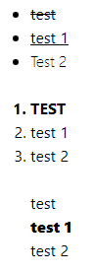

Arbitrary values
If you need to use a one-off value that doesn’t make sense to include in your theme, use square brackets to generate a property on the fly using any arbitrary value.
<p class="text-[#50d71e]">
<!-- ... -->
</p>
Background
Background color
- Control the background color of an element using the bg-{color} utilities.
- This class is used to specify the background color of an element. The background covers the total size of the element with padding and border but excluding margin. It makes the text so easy to read for the user.
Background Color classes:
bg-inherit | bg-current | bg-transparent | bg-black | bg-white | bg-slate-50
bg-slate-100 | bg-slate-200 | bg-slate-300 | bg-slate-400 | bg-slate-500 | bg-slate-600
bg-slate-700 | bg-slate-800 | bg-slate-900 | bg-slate-950 | bg-gray-50 | bg-gray-100
bg-gray-200 | bg-gray-300 | bg-gray-400 | bg-gray-500 | bg-gray-600 | bg-gray-700
bg-gray-800 | bg-gray-900 | bg-gray-950 | bg-zinc-50 | bg-zinc-100 | bg-zinc-200
bg-zinc-300 | bg-zinc-400 | bg-zinc-500 | bg-zinc-600 | bg-zinc-700 | bg-zinc-800
bg-zinc-900 | bg-zinc-950 | bg-neutral-50 | bg-neutral-100 | bg-neutral-200 | bg-neutral-300
bg-neutral-400 | bg-neutral-500 | bg-neutral-600 | bg-neutral-700 | bg-neutral-800 | bg-neutral-900
bg-neutral-950 | bg-stone-50 | bg-stone-100 | bg-stone-200 | bg-stone-300 | bg-stone-400
bg-stone-500 | bg-stone-600 | bg-stone-700 | bg-stone-800 | bg-stone-900 | bg-stone-950
bg-red-50 | bg-red-100 | bg-red-200 | bg-red-300 | bg-red-400 | bg-red-500
bg-red-600 | bg-red-700 | bg-red-800 | bg-red-900 | bg-red-950 | bg-orange-50
bg-orange-100 | bg-orange-200 | bg-orange-300 | bg-orange-400 | bg-orange-500 | bg-orange-600
bg-orange-700 | bg-orange-800 | bg-orange-900 | bg-orange-950 | bg-amber-50 | bg-amber-100
bg-amber-200 | bg-amber-300 | bg-amber-400 | bg-amber-500 | bg-amber-600 | bg-amber-700
bg-amber-800 | bg-amber-900 | bg-amber-950 | bg-yellow-50 | bg-yellow-100 | bg-yellow-200
bg-yellow-300 | bg-yellow-400 | bg-yellow-500 | bg-yellow-600 | bg-yellow-700 | bg-yellow-800
bg-yellow-900 | bg-yellow-950 | bg-lime-50 | bg-lime-100 | bg-lime-200 | bg-lime-300
bg-lime-400 | bg-lime-500 | bg-lime-600 | bg-lime-700 | bg-lime-800 | bg-lime-900
bg-lime-950 | bg-green-50 | bg-green-100 | bg-green-200 | bg-green-300 | bg-green-400
bg-green-500 | bg-green-600 | bg-green-700 | bg-green-800 | bg-green-900 | bg-green-950
bg-emerald-50 | bg-emerald-100 | bg-emerald-200 | bg-emerald-300 | bg-emerald-400 | bg-emerald-500
bg-emerald-600 | bg-emerald-700 | bg-emerald-800 | bg-emerald-900 | bg-emerald-950 | bg-teal-50
bg-teal-100 | bg-teal-200 | bg-teal-300 | bg-teal-400 | bg-teal-500 | bg-teal-600
bg-teal-700 | bg-teal-800 | bg-teal-900 | bg-teal-950 | bg-cyan-50 | bg-cyan-100
bg-cyan-200 | bg-cyan-300 | bg-cyan-400 | bg-cyan-500 | bg-cyan-600 | bg-cyan-700
bg-cyan-800 | bg-cyan-900 | bg-cyan-950 | bg-sky-50 | bg-sky-100 | bg-sky-200
bg-sky-300 | bg-sky-400 | bg-sky-500 | bg-sky-600 | bg-sky-700 | bg-sky-800
bg-sky-900 | bg-sky-950 | bg-blue-50 | bg-blue-100 | bg-blue-200 | bg-blue-300
bg-blue-400 | bg-blue-500 | bg-blue-600 | bg-blue-700 | bg-blue-800 | bg-blue-900
bg-blue-950 | bg-indigo-50 | bg-indigo-100 | bg-indigo-200 | bg-indigo-300 | bg-indigo-400
bg-indigo-500 | bg-indigo-600 | bg-indigo-700 | bg-indigo-800 | bg-indigo-900 | bg-indigo-950
bg-violet-50 | bg-violet-100 | bg-violet-200 | bg-violet-300 | bg-violet-400 | bg-violet-500
bg-violet-600 | bg-violet-700 | bg-violet-800 | bg-violet-900 | bg-violet-950 | bg-purple-50
bg-purple-100 | bg-purple-200 | bg-purple-300 | bg-purple-400 | bg-purple-500 | bg-purple-600
bg-purple-700 | bg-purple-800 | bg-purple-900 | bg-purple-950 | bg-fuchsia-50 | bg-fuchsia-100
bg-fuchsia-200 | bg-fuchsia-300 | bg-fuchsia-400 | bg-fuchsia-500 | bg-fuchsia-600 | bg-fuchsia-700
bg-fuchsia-800 | bg-fuchsia-900 | bg-fuchsia-950 | bg-pink-50 | bg-pink-100 | bg-pink-200
bg-pink-300 | bg-pink-400 | bg-pink-500 | bg-pink-600 | bg-pink-700 | bg-pink-800
bg-pink-900 | bg-pink-950 | bg-rose-50 | bg-rose-100 | bg-rose-200 | bg-rose-300
bg-rose-400 | bg-rose-500 | bg-rose-600 | bg-rose-700 | bg-rose-800 | bg-rose-900
bg-rose-950

Note: The color’s values can be changeable according to your need from 50-950.

Example:
<body class="text-center mx-4">
<h1 class="text-green-600 text-5xl font-bold">
Tailwind CSS Background Color Class
</h1>

<div class="mx-14 bg-green-200 text-justify p-4">
<p class="bg-transparent p-2">Transparent</p>
<p class="bg-current text-yellow-600 p-2">Current</p>
<p class="bg-white p-2"> White </p>
<p class="bg-black text-white p-2">Black</p>
<p class="bg-gray-700 p-2"> Gray</p>
<p class="bg-red-700 p-2"> Red</p>
<p class="bg-indigo-700 p-2">Indigo</p>
<p class="bg-blue-700 p-2"> Blue</p>
<p class="bg-green-700 p-2">Green</p>
<p class="bg-yellow-700 p-2"> Yellow</p>
<p class="bg-pink-700 p-2">Pink</p>
<p class="bg-purple-700 p-2"> Purple</p>
</div>
</body>

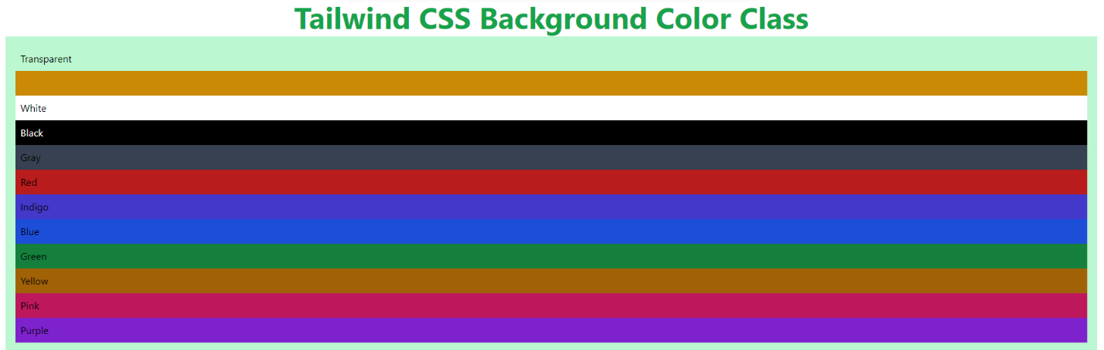

Example:
Design a layout using Tailwind CSS that consists of a container with a height of 350px, a yellow background, and padding. Inside this container, create two text blocks:
- The first block should occupy half the height of the container, have a blue background, display "Hello" in 90px red text and center-aligned.
- The second block should occupy one-fourth the height of the container, have a rose-colored background, display "Hello" in 90px green text and right-aligned
<div class="h-[350px] bg-yellow-300 p-5 m-3">
<div class="h-1/2 bg-blue-300 text-[90px] text-red-500 text-center m-3">Hello</div>
<div class="h-1/6 bg-rose-300 text-[90px] text-green-500 text-right m-3">Hello</div>
</div>
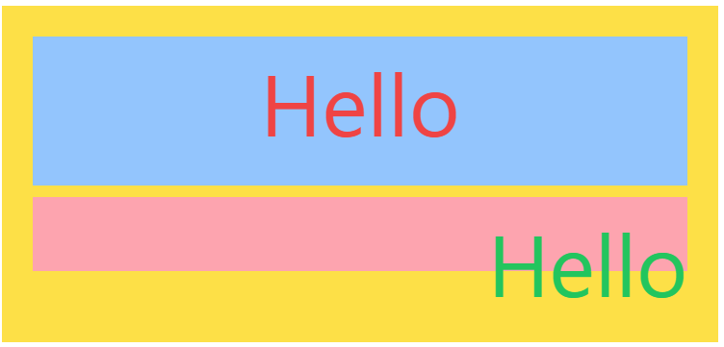

Background Attachment
Utilities for controlling how a background image behaves when scrolling.
bg-fixed (background-attachment: fixed; )
The background is fixed relative to the viewport. Even if an element has a scrolling mechanism, the background doesn't move with the element.
bg-local (background-attachment: local; )
The background is fixed relative to the element's contents. If the element has a scrolling mechanism, the background scrolls with the element's contents, and the background painting area and background positioning area are relative to the scrollable area of the element rather than to the border framing them.
bg-scroll (background-attachment: scroll; )
The background is fixed relative to the element itself and does not scroll with its contents.
Reference Link: https://tailwindcss.com/docs/background-attachment

Background Position
Utilities for controlling the position of an element's background image.
Use the bg-{side} utilities to control the position of an element’s background image.
bg-bottom | background-position: bottom;
bg-center | background-position: center;
bg-left | background-position: left;
bg-left-bottom | background-position: left bottom;
bg-left-top | background-position: left top;
bg-right | background-position: right;
bg-right-bottom | background-position: right bottom;
bg-right-top | background-position: right top;
bg-top | background-position: top;

Background Repeat
Utilities for controlling the repetition of an element's background image.
bg-repeat | background-repeat: repeat;
bg-no-repeat | background-repeat: no-repeat;
bg-repeat-x | background-repeat: repeat-x;
bg-repeat-y | background-repeat: repeat-y;
​
- Repeat
Use bg-repeat to repeat the background image both vertically and horizontally.
<div class="bg-repeat" style="background-image: url(...)"></div>
​
- No Repeat
Use bg-no-repeat when you don’t want to repeat the background image.
<div class="bg-no-repeat" style="background-image: url(...)"> </div>
​
- Repeat Horizontally
Use bg-repeat-x to repeat the background image only horizontally.
<div class="bg-repeat-x" style="background-image: url(...)"></div>
​
- Repeat Vertically
Use bg-repeat-y to repeat the background image only vertically.
<div class="bg-repeat-y" style="background-image: url(...)"></div>

Background Size
Utilities for controlling the background size of an element's background image.
bg-auto | background-size: auto;
bg-cover | background-size: cover;
bg-contain | background-size: contain;
​​
- Auto
Use bg-auto to display the background image at its default size.

<div class="bg-auto bg-no-repeat" style="background-image: url(...)"></div>
​
- Cover
Use bg-cover to scale the background image until it fills the background layer.
<div class="bg-cover" style="background-image: url(...)"></div>
​
- Contain
Use bg-contain to scale the background image to the outer edges without cropping or stretching.
<div class="bg-contain" style="background-image: url(...)"></div>

Examples
<div class="m-4 h-96 w-1/2 bg-[url('2.png')]"></div>


<div class="m-4 h-96 w-1/2 bg-[url('2.png')] bg-no-repeat bg-cover bg-center"></div>


For understanding purpose
Via the style attribute:
If you prefer to skip the config then you can just add it using the style attribute, like this:

<div style="background-image: url('../public/images/hero.jpg');"></div>

Via using an arbitrary value:
If you prefer not to use inline styles and have a single-use image then this is the best approach.

<div class="bg-[url('../public/images/hero.jpg')]"></div>

The background will move as you scroll
<div class="bg-[url(2.png)] h-72 p-5 m-6 overflow-scroll bg-local bg-cover">Kindly note take the content larger. (lorem*10)
</div>

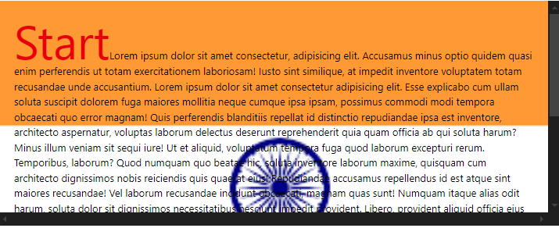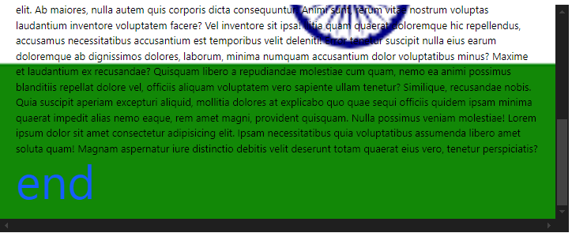
To set the background image to scroll with the content
<div class="bg-[url(2.png)] p-5 h-72 m-6 overflow-scroll bg-scroll bg-cover">Kindly note take the content larger. (lorem*10)
</div>

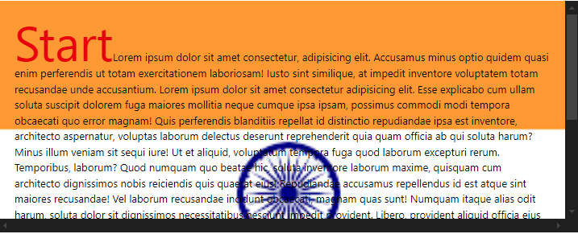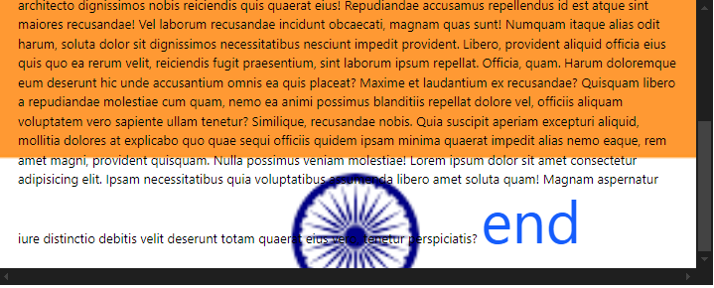
overflow-scroll:
Ensures that the content inside the div is scrollable when it overflows the defined height. This creates a vertical or horizontal scrollbar when necessary.

Background Image
Utilities for controlling an element's background image.
To give an element a linear gradient background, use one of the bg-gradient-{direction} utilities, in combination with the gradient color stop utilities.
Classes
bg-none | This class is used not to set any linear-gradient.
bg-gradient-to-t | This class is used to set the linear-gradient to the top.
bg-gradient-to-tr | This class is used to set the linear-gradient to the top right.
bg-gradient-to-r | This class is used to set the linear-gradient to right.
bg-gradient-to-br | This class is used to set the linear-gradient to the bottom right.
bg-gradient-to-b | This class is used to set the linear-gradient to the bottom.
bg-gradient-to-bl | This class is used to set the linear-gradient to the bottom left.
bg-gradient-to-l | This class is used to set the linear-gradient to left.
bg-gradient-to-tl | This class is used to set the linear-gradient to the top left.

Starting color
Set the starting color of a gradient using the from-{color} utilities.
<div class="bg-gradient-to-r from-indigo-500"></div>
​
Ending color
Set the ending color of a gradient using the to-{color} utilities.
<div class="bg-gradient-to-r from-cyan-500 to-blue-500"></div>
Gradients to do not fade in from transparent by default. To fade in from transparent, reverse the gradient direction and use a from-{color} utility.

Middle color
Add a middle color to a gradient using the via-{color} utilities.
<div class="bg-gradient-to-r from-indigo-500 via-purple-500 to-pink-500"></div>
Gradients with a from-{color} and via-{color} will fade out to transparent by default if no to-{color} is present.
​
Specifying stop positions
For more control over the gradient color stop positions, combine the from-{position}, via-{position} and to-{position} utilities with the gradient color utilities.

Example:
<div class="m-4 h-24 w-1/2 bg-gradient-to-r from-yellow-400 via-pink-500 to-blue-500"></div>
<div class="m-4 h-24 w-1/2 bg-gradient-to-t from-indigo-600"></div>
<div class="m-4 h-24 w-1/2 bg-gradient-to-tr from-pink-500 to-yellow-500"></div>
Output
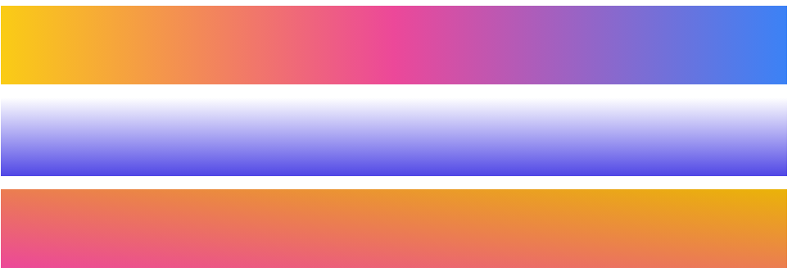

Add gradient to text

<h1 class=" text-9xl bg-gradient-to-r from-blue-600 via-green-500 to-indigo-400">Hello World</h1>
This will not add gradient to text. Follow below steps to add gradient to the text.

Step 1: Add the inline-block class to our element.

<h1 class=" text-9xl bg-gradient-to-r from-blue-600 via-green-500 to-indigo-400 inline-block">hello world</h1>

Now, the gradient takes up only the width of the text, instead of the width of the parent element.

Step 2: Make your text transparent
Make your text transparent using the text-transparent class.

<h1 class=" text-9xl bg-gradient-to-r from-blue-600 via-green-500 to-indigo-400 inline-block text-transparent">hello world</h1>

The text will disappear.

Step 3: Clip the text to the background
This is the most important thing for making gradient text, it uses the background-clip CSS property, which has multiple values and one of them is text, to use that specific property and value in Tailwind CSS we just need to add the bg-clip-text class.

<h1 class="text-9xl bg-gradient-to-r from-blue-600 via-green-500 to-indigo-400 inline-block text-transparent bg-clip-text ">hello world</h1>

- bg-gradient-to-r creates the gradient and makes it from left to right
- from-blue-600 sets our starting color, which will go on the left
- via-green-500 sets our middle color, which is optional
- to-indigo-400 sets our ending color, which will go on the right and can be optional if you want the end to be transparent
Background Opacity
Utilities for controlling the opacity of an element's background color.
Control the opacity of an element’s background color using the bg-opacity-{amount} utilities.
bg-opacity-0 | --tw-bg-opacity: 0;
bg-opacity-5 | --tw-bg-opacity: 0.05;
bg-opacity-10 | --tw-bg-opacity: 0.1;
bg-opacity-20 | --tw-bg-opacity: 0.2;
bg-opacity-25 | --tw-bg-opacity: 0.25;
bg-opacity-30 | --tw-bg-opacity: 0.3;
bg-opacity-40 | --tw-bg-opacity: 0.4;
bg-opacity-50 | --tw-bg-opacity: 0.5;
bg-opacity-60 | --tw-bg-opacity: 0.6;
bg-opacity-70 | --tw-bg-opacity: 0.7;
bg-opacity-75 | --tw-bg-opacity: 0.75;
bg-opacity-80 | --tw-bg-opacity: 0.8;
bg-opacity-90 | --tw-bg-opacity: 0.9;
bg-opacity-95 | --tw-bg-opacity: 0.95;
bg-opacity-100 | --tw-bg-opacity: 1;
Example:
<div class="h-48 w-1/4 bg-blue-900"></div>
<div class="h-48 w-1/4 bg-blue-900 bg-opacity-75"></div>
<div class="h-48 w-1/4 bg-blue-900 bg-opacity-50"></div>
<div class="h-48 w-1/4 bg-blue-900 bg-opacity-25"></div>


Borders
border-width
This class is used to set the border width of all four sides of an element.
Tailwind CSS follows a consistent naming convention for border width classes:
border-{side}-{width}.
side can be t (top), b (bottom), l (left), or r(right)

Border Width Classes:
border | border-0 | border-2 | border-4
border-8 | border-t | border-t-0 | border-t-2
border-t-4 | border-t-8 | border-r | border-r-0
border-r-2 | border-r-4 | border-r-8 | border-b
border-b-0 | border-b-2 | border-b-4 | border-b-8
border-l | border-l-0 | border-l-2 | border-l-4
border-l-8

border-color
This class is used to specify the border color of an element.
Border Color classes:
border-transparent | The border color will be transparent.
border-current | The border will color depend on the parent element color.
border-black | The border color will be black.
border-white | The border color will be white.
border-gray-50 | The border color will be gray.
border-red-50 | The border color will be red.
border-blue-50 | The border color will be blue.
border-indigo-50 | The border color will be indigo.
border-purple-50 | The border color will be purple.
border-green-50 | The border color will be green.
border-yellow-50 | The border color will be yellow.
border-pink-50 | The border color will be pink.

Note: The color’s values can be changeable according to your need from 50-900, the span should be 100, after the 100.

Example:
<div>
<div class="p-4 mt-1 border border-blue-700">Border 1</div>
<div class="p-4 mt-1 border-2 border-blue-700">Border 2</div>
<div class="p-4 mt-1 border-4 border-blue-700">Border 4</div>
<div class="p-4 mt-1 border-8 border-blue-700">Border 8</div>
</div>
Output:
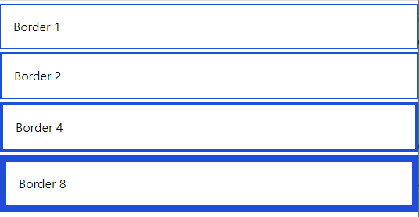
Example: Applying Border Color to Individual Sides
<div>
<div class="border-4 m-1 border-blue-100 border-t-blue-700 p-3">border top
color</div>
<div class="border-4 m-1 border-blue-100 border-l-blue-700 p-3">border lfet
color</div>
<div class="border-4 m-1 border-blue-100 border-b-blue-700 p-3">border
bottom color</div>
<div class="border-4 m-1 border-blue-100 border-r-blue-700 p-3">border right
color</div>
</div>
Output:
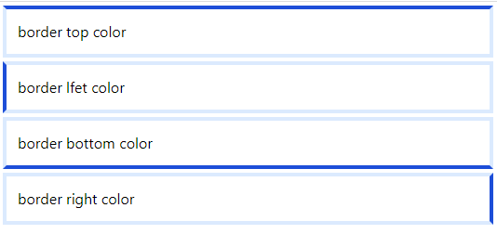
Example: Border color horizontal and vertical sides using border-{x|y}-{color}
<div>
<div class="border-4 m-1 border-blue-100 border-x-blue-700 p-3">border-x-blue-700</div>
<br>
<div class="border-4 m-1 border-blue-100 border-y-blue-700 p-3">border-y-blue-700</div>
</div>
Output:
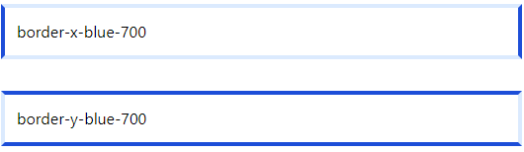

border-style
This class is used for controlling the style of an element’s borders.
Border Style Classes:
border-solid
border-dashed
border-dotted
border-double
border-none
border-hidden
Example: Border-style
<div class="w-96 rounded-sm border-8 border-blue-600 bg-red-400 border-solid p-4 m-2">rounded-sm</div>
<div class="w-96 rounded-md border-8 border-blue-600 bg-yellow-300 border-double p-4 m-2">rounded-md</div>
<div class="w-96 rounded-lg border-8 border-blue-600 bg-blue-300 border-dashed p-4 m-2">rounded-lg</div>
<div class="w-96 rounded-xl border-8 border-blue-600 bg-pink-300 border-dotted p-4 m-2">rounded-xl</div>
<div class="w-96 rounded-2xl border-8 border-blue-600 bg-green-300 border-none p-4 m-2">rounded-2xl</div>
Output:
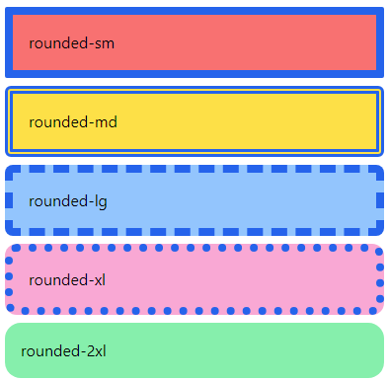

border-radius
Utilities for controlling the border radius of an element.
Use utilities like rounded-sm, rounded, or rounded-lg to apply different border radius sizes to an element.
rounded-none | border-radius: 0px;
rounded-sm | border-radius: 0.125rem; /* 2px */
rounded | border-radius: 0.25rem; /* 4px */
rounded-md | border-radius: 0.375rem; /* 6px */
rounded-lg | border-radius: 0.5rem; /* 8px */
rounded-xl | border-radius: 0.75rem; /* 12px */
rounded-2xl | border-radius: 1rem; /* 16px */
rounded-3xl | border-radius: 1.5rem; /* 24px */
rounded-full | border-radius: 9999px;

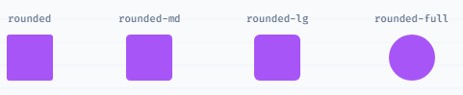
<div class="w-96 rounded-sm border-2 border-blue-600 bg-red-400 p-4 m-2">rounded-sm</div>
<div class="w-96 rounded-md border-2 border-blue-600 bg-yellow-300 p-4 m-2">rounded-md</div>
<div class="w-96 rounded-lg border-2 border-blue-600 bg-blue-300 p-4 m-2">rounded-lg</div>
<div class="w-96 rounded-xl border-2 border-blue-600 bg-pink-300 p-4 m-2">rounded-xl</div>
<div class="w-96 rounded-2xl border-2 border-blue-600 bg-green-300 p-4 m-2">rounded-2xl</div>
Output:
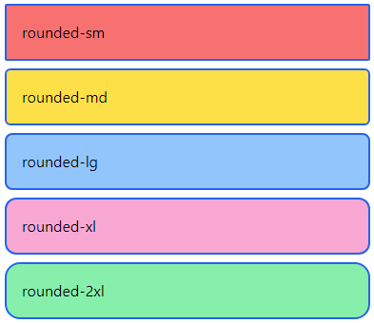
Example: Rounded Corners by Specific Sides
<div class="rounded-tl-lg border-blue-600 p-4 border-[2px] m-3">
rounded top-left</div>
<div class="rounded-b-lg border-blue-600 p-4 border-[2px] m-3">
rounded bottom</div>
<div class="rounded-r-lg border-blue-600 p-4 border-[2px] m-3">
rounded right</div>
<div class="rounded-l-lg border-blue-600 p-4 border-[2px] m-3">
rounded left</div>
Output:
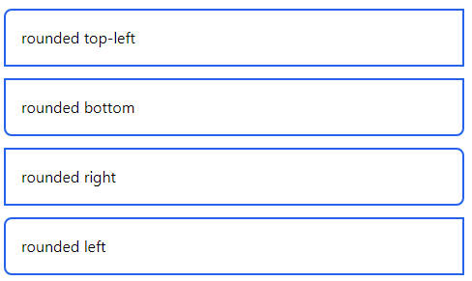

Layout
Container
- In Tailwind CSS, a container is used to fix the max-width of an element to match the min-width of the breakpoint. It comes very handy when content has to be displayed in a responsive manner to every breakpoint.
Breakpoints in tailwind CSS are as follows.
Breakpoint | min-width
sm | 640px
md | 768px
lg | 1024px
xl | 1280px
2xl | 1536px

Tailwind CSS does not center itself automatically and also does not contain any pre-defined padding.
The following are some utility classes that make the container class stand out.
mx-auto: To center the container, we use mx-auto utility class. It adjusts the margin of the container automatically so that the container appears to be in center.
Syntax:
<element class=" container mx-auto">...</element>
px-{size}: To add padding the container, we use px-{size} utility class. It adds horizontal padding to the container which is equal to the size mentioned.
Syntax:
<element class="container px-20">...</element>
Example:
<div class="container mx-auto p-4 bg-pink-200">
<p>Lorem ipsum dolor sit amet, consectetur adipisicing elit. Ut doloribus voluptates soluta corrupti debitis eos nihil beatae vitae, perspiciatis autem, quibusdam amet illum excepturi delectus quidem repellendus commodi velit quae?</p></div>
Display
Utilities for controlling the display box type of an element.
Use inline, inline-block, and block to control the flow of text and elements.
block | display: block;
inline-block | display: inline-block;
inline | display: inline;
hidden | display: none;

Example
<div>
When controlling the flow of text, using the CSS property
<p class="inline h-24 bg-red-200">display: inline</p>
will cause the text inside the element to wrap normally.</div>

<div>
While using the property
<p class="inline-block h-24 bg-yellow-200">display: inline-block</p>
will wrap the element to prevent the text inside from extending beyond its parent.
</div>

<div>
Lastly, using the property
<span class="block">display: block</span>
will put the element on its own line and fill its parent.
</div>
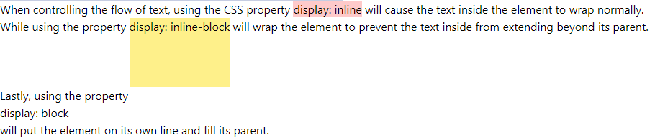
Floats
Utilities for controlling the wrapping of content around an element.
float-right | float: right;
float-left | float: left;
float-none | float: none;

Floating elements to the right
Use float-right to float an element to the right of its container.
<div class="m-4 p-4 bg-blue-100 h-40 w-1/2">
<img src="2.png" class="float-right px-4 w-48 h-24">
<p class="text-xl">Lorem ipsum dolor sit, amet consectetur adipisicing elit. Et perferendis nesciunt veniam explicabo atque quidem eligendi a fugiat officiis porro autem, saepe animi sapiente omnis quasi reprehenderit quis. Consequuntur, minus.</p>
</div>
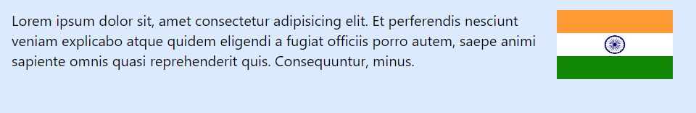
Floating elements to the left
Use float-left to float an element to the left of its container.
<div class="m-4 p-4 bg-blue-100 h-40 w-1/2">
<img src="2.png" class="float-left px-4 w-48 h-24">
<p class="text-xl ">Lorem ipsum dolor sit, amet consectetur adipisicing elit. Et perferendis nesciunt veniam explicabo atque quidem eligendi a fugiat officiis porro autem, saepe animi sapiente omnis quasi reprehenderit quis. Consequuntur, minus.</p>
</div>

Float None
<div class="m-4 p-4 bg-blue-100 h-52 w-1/2">
<img src="2.png" class="float-none px-4 w-48 h-24">
<p class="text-xl ">Lorem ipsum dolor sit, amet consectetur adipisicing elit. Et perferendis nesciunt veniam explicabo atque quidem eligendi a fugiat officiis porro autem, saepe animi sapiente omnis quasi reprehenderit quis. Consequuntur, minus.</p>
</div>
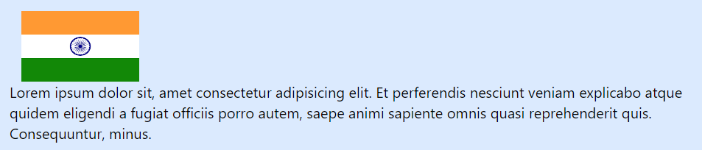
Effects
Box Shadow
Utilities for controlling the box shadow of an element.
Use the shadow-sm, shadow, shadow-md, shadow-lg, shadow-xl, or shadow-2xl utilities to apply different sized outer box shadows to an element.
shadow-sm
shadow
shadow-md
shadow-lg
shadow-xl
shadow-2xl
​​
Example:
<div class="h-24 w-24 bg-black "></div>
<div class="h-24 w-24 bg-black shadow-2xl bg-yellow-200"></div>
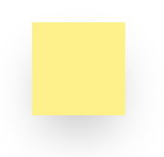
Box Shadow Color
Utilities for controlling the color of a box shadow.
Use the shadow-{color} utilities to change the color of an existing box shadow. By default colored shadows have an opacity of 100%, but you can adjust this using the opacity modifier.
shadow-inherit | shadow-current | shadow-transparent | shadow-black | shadow-white
shadow-slate-50 | shadow-slate-100 | shadow-slate-200 | shadow-slate-300 | shadow-slate-400
shadow-slate-500 | shadow-slate-600 | shadow-slate-700 | shadow-slate-800 | shadow-slate-900
shadow-slate-950 | shadow-gray-50 | shadow-gray-100 | shadow-gray-200 | shadow-gray-300
shadow-gray-400 | shadow-gray-500 | shadow-gray-600 | shadow-gray-700 | shadow-gray-800
shadow-gray-900 | shadow-gray-950 | shadow-zinc-50 | shadow-zinc-100 | shadow-zinc-200
shadow-zinc-300 | shadow-zinc-400 | shadow-zinc-500 | shadow-zinc-600 | shadow-zinc-700
shadow-zinc-800 | shadow-zinc-900 | shadow-zinc-950 | shadow-neutral-50 | shadow-neutral-100
shadow-neutral-200 | shadow-neutral-300 | shadow-neutral-400 | shadow-neutral-500 | shadow-neutral-600
shadow-neutral-700 | shadow-neutral-800 | shadow-neutral-900 | shadow-neutral-950 | shadow-stone-50
shadow-stone-100 | shadow-stone-200 | shadow-stone-300 | shadow-stone-400 | shadow-stone-500
shadow-stone-600 | shadow-stone-700 | shadow-stone-800 | shadow-stone-900 | shadow-stone-950
shadow-red-50 | shadow-red-100 | shadow-red-200 | shadow-red-300 | shadow-red-400
shadow-red-500 | shadow-red-600 | shadow-red-700 | shadow-red-800 | shadow-red-900
shadow-red-950 | shadow-orange-50 | shadow-orange-100 | shadow-orange-200 | shadow-orange-300
shadow-orange-400 | shadow-orange-500 | shadow-orange-600 | shadow-orange-700 | shadow-orange-800
shadow-orange-900 | shadow-orange-950 | shadow-amber-50 | shadow-amber-100 | shadow-amber-200
shadow-amber-300 | shadow-amber-400 | shadow-amber-500 | shadow-amber-600 | shadow-amber-700
shadow-amber-800 | shadow-amber-900 | shadow-amber-950 | shadow-yellow-50 | shadow-yellow-100
shadow-yellow-200 | shadow-yellow-300 | shadow-yellow-400 | shadow-yellow-500 | shadow-yellow-600
shadow-yellow-700 | shadow-yellow-800 | shadow-yellow-900 | shadow-yellow-950 | shadow-lime-50
shadow-lime-100 | shadow-lime-200 | shadow-lime-300 | shadow-lime-400 | shadow-lime-500
shadow-lime-600 | shadow-lime-700 | shadow-lime-800 | shadow-lime-900 | shadow-lime-950
shadow-green-50 | shadow-green-100 | shadow-green-200 | shadow-green-300 | shadow-green-400
shadow-green-500 | shadow-green-600 | shadow-green-700 | shadow-green-800 | shadow-green-900
shadow-green-950 | shadow-emerald-50 | shadow-emerald-100 | shadow-emerald-200 | shadow-emerald-300
shadow-emerald-400 | shadow-emerald-500 | shadow-emerald-600 | shadow-emerald-700 | shadow-emerald-800
shadow-emerald-900 | shadow-emerald-950 | shadow-teal-50 | shadow-teal-100 | shadow-teal-200
shadow-teal-300 | shadow-teal-400 | shadow-teal-500 | shadow-teal-600 | shadow-teal-700
shadow-teal-800 | shadow-teal-900 | shadow-teal-950 | shadow-cyan-50 | shadow-cyan-100
shadow-cyan-200 | shadow-cyan-300 | shadow-cyan-400 | shadow-cyan-500 | shadow-cyan-600
shadow-cyan-700 | shadow-cyan-800 | shadow-cyan-900 | shadow-cyan-950 | shadow-sky-50
shadow-sky-100 | shadow-sky-200 | shadow-sky-300 | shadow-sky-400 | shadow-sky-500
shadow-sky-600 | shadow-sky-700 | shadow-sky-800 | shadow-sky-900 | shadow-sky-950
shadow-blue-50 | shadow-blue-100 | shadow-blue-200 | shadow-blue-300 | shadow-blue-400
shadow-blue-500 | shadow-blue-600 | shadow-blue-700 | shadow-blue-800 | shadow-blue-900
shadow-blue-950 | shadow-indigo-50 | shadow-indigo-100 | shadow-indigo-200 | shadow-indigo-300
shadow-indigo-400 | shadow-indigo-500 | shadow-indigo-600 | shadow-indigo-700 | shadow-indigo-800
shadow-indigo-900 | shadow-indigo-950 | shadow-violet-50 | shadow-violet-100 | shadow-violet-200
shadow-violet-300 | shadow-violet-400 | shadow-violet-500 | shadow-violet-600 | shadow-violet-700
shadow-violet-800 | shadow-violet-900 | shadow-violet-950 | shadow-purple-50 | shadow-purple-100
shadow-purple-200 | shadow-purple-300 | shadow-purple-400 | shadow-purple-500 | shadow-purple-600
shadow-purple-700 | shadow-purple-800 | shadow-purple-900 | shadow-purple-950 | shadow-fuchsia-50
shadow-fuchsia-100 | shadow-fuchsia-200 | shadow-fuchsia-300 | shadow-fuchsia-400 | shadow-fuchsia-500
shadow-fuchsia-600 | shadow-fuchsia-700 | shadow-fuchsia-800 | shadow-fuchsia-900 | shadow-fuchsia-950
shadow-pink-50 | shadow-pink-100 | shadow-pink-200 | shadow-pink-300 | shadow-pink-400
shadow-pink-500 | shadow-pink-600 | shadow-pink-700 | shadow-pink-800 | shadow-pink-900
shadow-pink-950 | shadow-rose-50 | shadow-rose-100 | shadow-rose-200 | shadow-rose-300
shadow-rose-400 | shadow-rose-500 | shadow-rose-600 | shadow-rose-700 | shadow-rose-800
shadow-rose-900 | shadow-rose-950

Flexbox
- The CSS flexbox is a vital feature to develop the frontend.
- It is the alternative of CSS flex Property for fast development of front-end. It is used to set the length of flexible items. The flex class is much responsive and mobile-friendly.
Display
flex: It is used to display an element as a block-level flex container.
<div class="flex p-3 bg-blue-300 text-white">
<div class="p-2 bg-red-400">Flex item 1</div>
<div class="p-2 bg-yellow-400">Flex item 2</div>
<div class="p-2 bg-green-300">Flex item 3</div>
</div>
inline-flex: It is used to display an element as an inline-level flex container.
<div class="inline-flex p-3 bg-blue-300 text-white">
<div class="p-2 bg-red-400">Flex item 1</div>
<div class="p-2 bg-yellow-400">Flex item 2</div>
<div class="p-2 bg-green-300">Flex item 3</div>
</div>
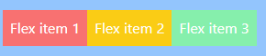
Flex Direction
Utilities for controlling the direction of flex items.
flex-row | flex-direction: row;
flex-row-reverse | flex-direction: row-reverse;
flex-col | flex-direction: column;
flex-col-reverse | flex-direction: column-reverse;
Row
Use flex-row to position flex items horizontally in the same direction as text:
<div class="w-1/2 flex flex-row bg-black p-4">
<div class="p-2 bg-red-400">Flex item 1</div>
<div class="p-2 bg-yellow-400">Flex item 2</div>
<div class="p-2 bg-green-300">Flex item 3</div>
</div>
Row reversed
Use flex-row-reverse to position flex items horizontally in the opposite direction:
<div class="w-1/2 flex flex-row-reverse bg-black p-4">
<div class="p-2 bg-red-400">Flex item 1</div>
<div class="p-2 bg-yellow-400">Flex item 2</div>
<div class="p-2 bg-green-300">Flex item 3</div>
</div>
Column
Use flex-col to position flex items vertically:
<div class="m-4 inline-flex flex-col bg-black p-4">
<div class="p-2 bg-red-400">Flex item 1</div>
<div class="p-2 bg-yellow-400">Flex item 2</div>
<div class="p-2 bg-green-300">Flex item 3</div>
</div>​
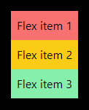
Column reversed
Use flex-col-reverse to position flex items vertically in the opposite direction:
<div class="inline-flex flex-col-reverse bg-black p-4">
<div class="p-2 bg-red-400">Flex item 1</div>
<div class="p-2 bg-yellow-400">Flex item 2</div>
<div class="p-2 bg-green-300">Flex item 3</div>
</div>​
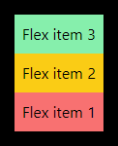
Flex wrap
Wrap
Use .flex-wrap to allow flex items to wrap:

<div class="m-24 w-1/4 flex flex-wrap bg-green-200 p-4 text-center text-lg">
<div class="bg-green-900 w-24 h-12">1</div>
<div class="bg-green-800 w-24 h-12">2</div>
<div class="bg-green-700 w-24 h-12">3</div>
<div class="bg-green-600 w-24 h-12">4</div>
<div class="bg-green-500 w-24 h-12">5</div>
<div class="bg-green-400 w-24 h-12">6</div>
</div>

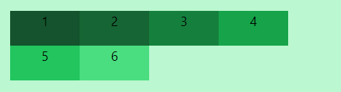

No Wrap
Use .flex-no-wrap to prevent flex items from wrapping, causing inflexible items to overflow the container if necessary:
<div class="m-24 w-1/4 flex flex-no-wrap bg-red-200 p-4 text-center text-xl">
<div class="bg-red-900 w-24 h-12">1</div>
<div class="bg-red-800 w-24 h-12">2</div>
<div class="bg-red-700 w-24 h-12">3</div>
<div class="bg-red-600 w-24 h-12">4</div>
<div class="bg-red-500 w-24 h-12">5</div>
<div class="bg-red-400 w-24 h-12">6</div>
</div>

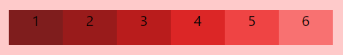

<div class="m-24 w-1/4 flex flex-no-wrap bg-red-200 p-4 text-center text-xl">
<div class="flex-none bg-red-900 w-24 h-12">1</div>
<div class="flex-none bg-red-800 w-24 h-12">2</div>
<div class="flex-none bg-red-700 w-24 h-12">3</div>
<div class="flex-none bg-red-600 w-24 h-12">4</div>
<div class="flex-none bg-red-500 w-24 h-12">5</div>
<div class="flex-none bg-red-400 w-24 h-12">6</div>
</div>
Note: Use flex-none to prevent a flex item from growing or shrinking
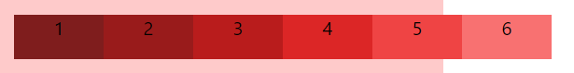

Wrap reversed
Use .flex-wrap-reverse to wrap flex items in the reverse direction:

<div class="m-24 w-1/4 flex flex-wrap-reverse bg-blue-200 p-4 text-center text-xl">
<div class="bg-blue-900 w-24 h-12">1</div>
<div class="bg-blue-800 w-24 h-12">2</div>
<div class="bg-blue-700 w-24 h-12">3</div>
<div class="bg-blue-600 w-24 h-12">4</div>
<div class="bg-blue-500 w-24 h-12">5</div>
<div class="bg-blue-400 w-24 h-12">6</div>
</div>

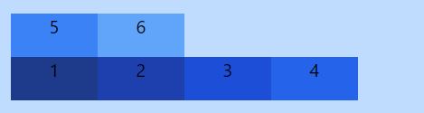

Box Alignment
Justify Content
Utilities for controlling how flex and grid items are positioned along a container's main axis.

justify-start | justify-content: flex-start;
justify-end | justify-content: flex-end;
justify-center | justify-content: center;
justify-between | justify-content: space-between;
justify-around | justify-content: space-around;
justify-evenly | justify-content: space-evenly;
​
Start
Use justify-start to justify items against the start of the container’s main axis:
<div class="w-1/2 flex justify-start bg-black p-4 m-4">
<div class="p-2 bg-red-400">Flex item 1</div>
<div class="p-2 bg-yellow-400">Flex item 2</div>
<div class="p-2 bg-green-300">Flex item 3</div>
</div>
​

Center
Use justify-center to justify items along the center of the container’s main axis:
​ <div class="w-1/2 flex justify-center bg-black p-4 m-4">
<div class="p-2 bg-red-400">Flex item 1</div>
<div class="p-2 bg-yellow-400">Flex item 2</div>
<div class="p-2 bg-green-300">Flex item 3</div>
</div>

End
Use justify-end to justify items against the end of the container’s main axis:
<div class="w-1/2 flex justify-end bg-black p-4 m-4">
<div class="p-2 bg-red-400">Flex item 1</div>
<div class="p-2 bg-yellow-400">Flex item 2</div>
<div class="p-2 bg-green-300">Flex item 3</div>
</div>

Space between
Use justify-between to justify items along the container’s main axis such that there is an equal amount of space between each item:
<div class="w-1/2 flex justify-between bg-black p-4 m-4">
<div class="p-2 bg-red-400">Flex item 1</div>
<div class="p-2 bg-yellow-400">Flex item 2</div>
<div class="p-2 bg-green-300">Flex item 3</div>
</div>
​

Space around
Use justify-around to justify items along the container’s main axis such that there is an equal amount of space on each side of each item:
<div class="w-1/2 flex justify-around bg-black p-4 m-4">
<div class="p-2 bg-red-400">Flex item 1</div>
<div class="p-2 bg-yellow-400">Flex item 2</div>
<div class="p-2 bg-green-300">Flex item 3</div>
</div>
​
Space evenly
Use justify-evenly to justify items along the container’s main axis such that there is an equal amount of space around each item, but also accounting for the doubling of space you would normally see between each item when using justify-around:
<div class="w-1/2 flex justify-evenly bg-black p-4 m-4">
<div class="p-2 bg-red-400">Flex item 1</div>
<div class="p-2 bg-yellow-400">Flex item 2</div>
<div class="p-2 bg-green-300">Flex item 3</div>
</div>
​
Justify Items
This class accepts two values in tailwind CSS. It is the alternative to the CSS justify-items property. This class is used for controlling how grid items are aligned along their inline axis.
Justify Items:
justify-items-auto
justify-items-start
justify-items-end
justify-items-center
justify-items-stretch

justify-items-auto: This class is used to justify grid items automatically on their inline axis.
<element class="justify-items-auto">...</element>

Example:
<div id="main" class="w-1/2 grid justify-items-auto grid-cols-3 bg-black m-4">
<div class="bg-green-500 rounded-lg m-4 h-12">1</div>
<div class="bg-green-500 rounded-lg m-4 h-12">2</div>
<div class="bg-green-500 rounded-lg m-4 h-12">3</div>
<div class="bg-green-500 rounded-lg m-4 h-12">4</div>
<div class="bg-green-500 rounded-lg m-4 h-12">5</div>
<div class="bg-green-500 rounded-lg m-4 h-12">6</div>
</div>
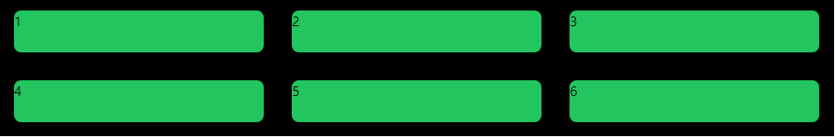

justify-items-start: This class is used to justify grid items against the start of their inline axis.
<element class="justify-items-start">...</element>

Example:
<div id="main" class="w-1/2 grid justify-items-start grid-cols-3 bg-black m-4">
<div class="bg-green-500 rounded-lg m-4 h-12 w-24">1</div>
<div class="bg-green-500 rounded-lg m-4 h-12 w-24">2</div>
<div class="bg-green-500 rounded-lg m-4 h-12 w-24">3</div>
<div class="bg-green-500 rounded-lg m-4 h-12 w-24">4</div>
<div class="bg-green-500 rounded-lg m-4 h-12 w-24">5</div>
<div class="bg-green-500 rounded-lg m-4 h-12 w-24">6</div>
</div>
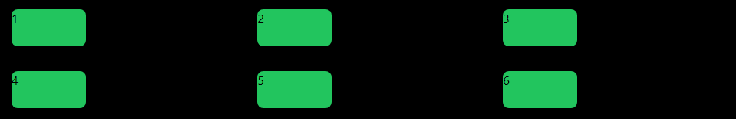

justify-items-end: This class is used to justify grid items against the end of their inline axis.
<element class="justify-items-end">...</element>

Example:
<div id="main" class="w-1/2 grid justify-items-end grid-cols-3 bg-black m-4">
<div class="bg-green-500 rounded-lg m-4 h-12 w-24">1</div>
<div class="bg-green-500 rounded-lg m-4 h-12 w-24">2</div>
<div class="bg-green-500 rounded-lg m-4 h-12 w-24">3</div>
<div class="bg-green-500 rounded-lg m-4 h-12 w-24">4</div>
<div class="bg-green-500 rounded-lg m-4 h-12 w-24">5</div>
<div class="bg-green-500 rounded-lg m-4 h-12 w-24">6</div>
</div>
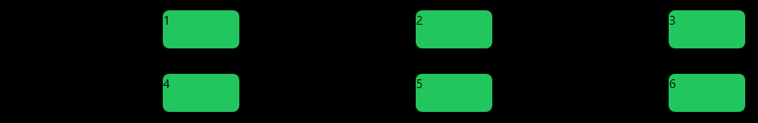

justify-items-center: This class is used to justify grid items along their inline axis.
<element class="jjustify-items-center">...</element>

Example:
<div id="main" class="w-1/2 grid justify-items-center grid-cols-3 bg-black m-4">
<div class="bg-green-500 rounded-lg m-4 h-12 w-24">1</div>
<div class="bg-green-500 rounded-lg m-4 h-12 w-24">2</div>
<div class="bg-green-500 rounded-lg m-4 h-12 w-24">3</div>
<div class="bg-green-500 rounded-lg m-4 h-12 w-24">4</div>
<div class="bg-green-500 rounded-lg m-4 h-12 w-24">5</div>
<div class="bg-green-500 rounded-lg m-4 h-12 w-24">6</div>
</div>
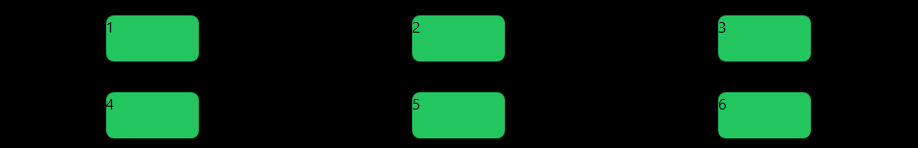

justify-items-stretch: This class is used to stretch items along their inline axis.
<element class="justify-items-stretch">...</element>

Example:
<div id="main" class="w-1/2 grid justify-items-stretch grid-cols-3 bg-black m-4">
<div class="bg-green-500 rounded-lg m-4 h-12">1</div>
<div class="bg-green-500 rounded-lg m-4 h-12">2</div>
<div class="bg-green-500 rounded-lg m-4 h-12">3</div>
<div class="bg-green-500 rounded-lg m-4 h-12">4</div>
<div class="bg-green-500 rounded-lg m-4 h-12">5</div>
<div class="bg-green-500 rounded-lg m-4 h-12">6</div>
</div>
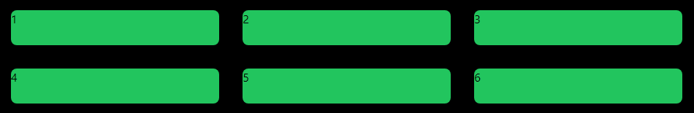

Grid

Grid Template Columns
It is used to set the number of columns and size of the columns of the grid, here we will do the same but for fast development of front-end. The number of columns is set by the number of values given to this class.
grid-cols-1 | Each row concedes only one column.
grid-cols-2 | Each row concedes only two columns.
grid-cols-3 | Each row concedes only three columns.
grid-cols-4 | Each row concedes only four columns.
grid-cols-5 | Each row concedes only five columns.
grid-cols-6 | Each row concedes six columns.
grid-cols-7 | Each row concedes seven-columns.
grid-cols-8 | Each row concedes eight columns.
grid-cols-9 | Each row concedes nine columns.
grid-cols-10 | Each row concedes ten columns.
grid-cols-11 | Each row concedes eleven columns.
grid-cols-12 | Each row concedes twelve columns.
grid-cols-none | Does not follow the grid-column property.

Syntax:
<element class="grid grid-cols-number"> Contents... </element>

Gap
Utilities for controlling gutters between grid and flexbox items.

gap-0 | gap-x-0 | gap-y-0 | gap-px | gap-x-px
gap-y-px | gap-0.5 | gap-x-0.5 | gap-y-0.5 | gap-1
gap-x-1 | gap-y-1 | gap-1.5 | gap-x-1.5 | gap-y-1.5
gap-2 | gap-x-2 | gap-y-2 | gap-2.5 | gap-x-2.5
gap-y-2.5 | gap-3 | gap-x-3 | gap-y-3 | gap-3.5
gap-x-3.5 | gap-y-3.5 | gap-4 | gap-x-4 | gap-y-4
gap-5 | gap-x-5 | gap-y-5 | gap-6 | gap-x-6
gap-y-6 | gap-7 | gap-x-7 | gap-y-7 | gap-8
gap-x-8 | gap-y-8 | gap-9 | gap-x-9 | gap-y-9
gap-10 | gap-x-10 | gap-y-10 | gap-11 | gap-x-11
gap-y-11 | gap-12 | gap-x-12 | gap-y-12 | gap-14
gap-x-14 | gap-y-14 | gap-16 | gap-x-16 | gap-y-16
gap-20 | gap-x-20 | gap-y-20 | gap-24 | gap-x-24
gap-y-24 | gap-28 | gap-x-28 | gap-y-28 | gap-32
gap-x-32 | gap-y-32 | gap-36 | gap-x-36 | gap-y-36
gap-40 | gap-x-40 | gap-y-40 | gap-44 | gap-x-44
gap-y-44 | gap-48 | gap-x-48 | gap-y-48 | gap-52
gap-x-52 | gap-y-52 | gap-56 | gap-x-56 | gap-y-56
gap-60 | gap-x-60 | gap-y-60 | gap-64 | gap-x-64
gap-y-64 | gap-72 | gap-x-72 | gap-y-72 | gap-80
gap-x-80 | gap-y-80 | gap-96 | gap-x-96 | gap-y-96

Example:
<div id="main" class="grid grid-cols-4 gap-2 p-4">
<div class="bg-green-300 h-12">1</div>
<div class="bg-green-500 h-12">2</div>
<div class="bg-green-300 h-12">3</div>
<div class="bg-green-500 h-12">4</div>
<div class="bg-green-300 h-12">5</div>
<div class="bg-green-500 h-12">6</div>
</div>

Tailwind modifiers
Pseudo-classes like :hover, :focus, :active, :visited
- Tailwind CSS uses the hover, focus, active, visited variants to style an element when the user mouse move over it, focuses it, actively clicks/tapped it and visited it.
- These variants allow you to create interactive and dynamic user interfaces without writing custom CSS.
Below are examples of several pseudo-class states supported in Tailwind CSS.
- Hover: The hover variant is used to style an element when the user hovers the mouse pointer over it. The modifier used is hover:
  - For example, you can use the hover:bg-red-500 class to change the background color of an element to red when the user hovers the mouse over it.

- Focus: Applied when an element has the focus. It is also enabled by default in Tailwind CSS. The modifier used is focus:
  - For example, you can use the focus:bg-red-500 class to change the background color of an element to red when an element has the focus.

- Active: Applied when an element is being activated by the user. The modifier used is active:
  - For example, you can use the active:bg-red-500 class to change the background color of an element to red when an element is being activated by the user.

- Visited: Applied once a user has visited a link. The modifier used is visited:
  - For example, you can use the visited:bg-red-500 class to change the background color of an element to red when a user has visited a link.

Example to understand pseudo class
<head><script src="https://cdn.tailwindcss.com"></script></head>
<body>
<a href="#" class="bg-pink-900 p-4 px-4 text-white m-4 hover:bg-black active:bg-red-500 visited:bg-yellow-500 focus:bg-green-600">Click here to check effects</a>
</body>
Output
Initially
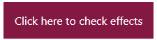
After Hover
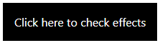
Active
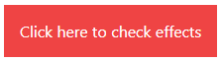
Focus
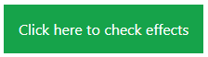
Visited

Pseudo-elements like ::before , ::after, ::first-line, ::first-letter
Use the content-{value} utilities along with the before and after variant modifiers to set the contents of the ::before and ::after pseudo-elements.

Before ::before
- This pseudo-element ::before allows us to add content before an element. It's like having a virtual container right before the actual content of an element.
- By using the ::before pseudo-element, we can insert content before the actual content of an element.

After ::after
- Similar to ::before, Pseudo-element ::after allows us to add content after an element. It's like having a virtual container right after the actual content of an element.
- By using the ::after pseudo-element, we can insert content after the actual content of an element.
This way, we can add extra visual elements or important information to our web page without modifying the original HTML structure.

Here's a simple example of Tailwind CSS code for the ::after and ::before utilities:
<p class="text-7xl m-4 before:content-['before'] before:text-green-500 after:content-['Hello'] after:text-red-500 after:text-5xl"> Lorem ipsum dolor sit amet </p>

Output:

First Letter ::first-letter
- The ::first-letter pseudo-element allows you to style the first letter of a block of text or a paragraph in a unique way.
- It can be used to make the first letter bigger, apply a different font, change its color, or add decorative elements to enhance the visual appeal.
- This way, you can easily customize the initial letter without altering the rest of the text.
First Line ::first-line
- The ::first-line pseudo-element allows you to style the first line of a block of text or a paragraph separately.
- It's like having a special focus on the first line of your content.
Here's a simple example of Tailwind CSS code for the ::first-letter and ::first-line utilities:
<p class="p-4 first-line:uppercase first-line:font-bold first-letter:text-9xl first-letter:text-red-500 first-line:text-blue-400 text-3xl">
Lorem ipsum, dolor sit amet consectetur adipisicing elit. Nostrum molestias repudiandae ullam voluptatibus qui eveniet odit, labore saepe expedita consectetur consequatur et maxime culpa praesentium aspernatur fugit? Asperiores, molestiae sint. Lorem, ipsum dolor sit amet consectetur adipisicing elit. Unde iste praesentium vitae ipsum ex eligendi esse sequi. Eum blanditiis voluptate cum nemo labore molestiae deleniti, enim, quos quod optio numquam.
</p>
Output:
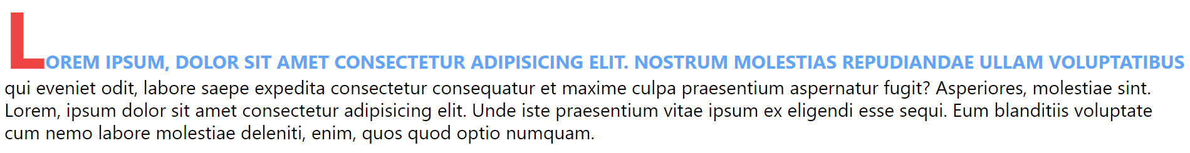

Referencing an attribute value
These content utilities even support CSS features like the attr() function, which you can use to reference a value stored in an attribute:
Example:
<div before="Hello World" class="before:content-[attr(before)]"></div>
Output: Hello World

Using spaces and underscores
Since whitespace denotes the end of a class in HTML, replace any spaces in an arbitrary value with an underscore:
Example:
<div class="before:content-['Hello_World']"></div>
Output: Hello World

If you need to include an actual underscore, you can do this by escaping it with a backslash:
Example:
<div class="before:content-['Hello\_World']"></div>
Output: Hello_World

Transitions and Animation
transition-property
- Utilities for controlling which CSS properties transition.
- Controlling transitioned properties
- Use the transition-{properties} utilities to specify which properties should transition when they change.

Tailwind class | CSS Property
transition-none  transition-all | transition-property: none;  transition-property: all;
transition | transition-property: color, background-color, border-color, text-decoration-color, fill, stroke, opacity, box-shadow, transform, filter, backdrop-filter;
transition-colors | transition-property: color, background-color, border-color, text-decoration-color, fill, stroke;
transition-shadow | transition-property: box-shadow;

transition-duration
- Utilities for controlling the duration of CSS transitions.
- Changing transition duration
- Use the duration-{amount} utilities to control an element’s transition-duration.

Tailwind class | CSS Property
duration-0 | transition-duration: 0s;
duration-75 | transition-duration: 75ms;
duration-100 | transition-duration: 100ms;
duration-150 | transition-duration: 150ms;
duration-200 | transition-duration: 200ms;
duration-300 | transition-duration: 300ms;
duration-500 | transition-duration: 500ms;
duration-700 | transition-duration: 700ms;
duration-1000 | transition-duration: 1000ms;

transition-delay
- Utilities for controlling the delay of CSS transitions.
- Delaying transitions
- Use the delay-{amount} utilities to control an element’s transition-delay.

Tailwind class | CSS Property
delay-0 | transition- delay: 0s;
delay-75 | transition- delay: 75ms;
delay-100 | transition- delay: 100ms;
delay-150 | transition- delay: 150ms;
delay-200 | transition- delay: 200ms;
delay-300 | transition- delay: 300ms;
delay-500 | transition- delay: 500ms;
delay-700 | transition- delay: 700ms;
delay-1000 | transition- delay: 1000ms;

Example:
<button class="px-10 py-4 bg-black text-white my-11 mx-4 text-2xl hover:px-11 hover:py-5 hover:text-black hover:bg-white hover:border-2 hover:border-black rounded-md delay-1000 transition-all duration-1000">Click Here</button>

animation
Utilities for animating elements with CSS animations.
Spin
Add the animate-spin utility to add a linear spin animation to elements like loading indicators.
Ping
Add the animate-ping utility to make an element scale and fade like a radar ping or ripple of water — useful for things like notification badges.
Pulse
Add the animate-pulse utility to make an element gently fade in and out — useful for things like skeleton loaders.
Bounce
Add the animate-bounce utility to make an element bounce up and down — useful for things like “scroll down” indicators.
Example:
<div class="p-4 m-4"></div>
<div class="w-32 m-auto h-32 rounded-full bg-blue-500 animate-bounce text-white p-4">Bounce</div>
<div class="w-32 m-auto h-32 bg-red-500 animate-spin text-white p-4">Spin</div>
<div class="w-32 h-32 m-auto bg-green-500 animate-pulse text-white p-4">Pulse</div>
<div class="p-5 m-5"></div>
<div class="w-32 m-auto h-32 bg-purple-500 animate-ping text-white p-4">Ping</div>
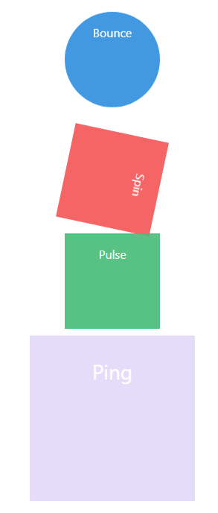
Responsive Design
Using responsive utility variants to build adaptive user interfaces.
- Every utility class in Tailwind can be applied conditionally at different breakpoints, which makes it a piece of cake to build complex responsive interfaces without ever leaving your HTML.
- Without below line, a website might not display correctly on mobile devices, often causing the content to be too large or too small to read easily.
<head><meta name="viewport" content="width=device-width, initial-scale=1.0"></head>
There are five breakpoints by default, inspired by common device resolutions:
Breakpoint prefix | Minimum width | CSS
sm | 640px | @media(min-width: 640px){ ... }
md | 768px | @media(min-width: 768px){ ... }
lg | 1024px | @media (min-width: 1024px){ ... }
xl | 1280px | @media (min-width: 1280px){ ... }
2xl | 1536px | @media (min-width: 1536px){ ... }
To add a utility but only have it take effect at a certain breakpoint, all you need to do is prefix the utility with the breakpoint name, followed by the : character
<!-- Width of 16 by default, 32 on medium screens, and 48 on large screens -->
<head><meta name="viewport" content="width=device-width, initial-scale=1.0"></head>
<img class="w-16 md:w-32 lg:w-48" src="2.png">
Customizing Default Tailwind CSS classes
Often the biggest challenge when working with a framework is figuring out what you’re supposed to do when there’s something you need that the framework doesn’t handle for you.
​
Customizing your theme
If you want to change things like your color palette, spacing scale, typography scale, or breakpoints, add your customizations to the theme section of your tailwind.config.js file

Using arbitrary values
When you find yourself really needing something which is not already available in tailwind, use Tailwind’s square bracket notation to generate a class on the fly with any arbitrary value:
Example
<head>
<script src="https://cdn.tailwindcss.com"></script>
<script>
tailwind.config = {
theme: {
colors: {
ljuPurple: 'purple',
},
fontSize:{
ljusize:'30px',
}
}
}
</script></head>
<p class="bg-ljuPurple text-[#f3f3a2] text-ljusize">Customizing Default Tailwind CSS classes</p>

Kindly note that if you add default CSS classes along with custom classes, the default class styles may not apply correctly. Create a new file and add the script as shown in the code above.
Example
Design a link and a button using tailwind css as shown in below image.

Add link “Click Me” and design it as shown in above image. Add hover effect and link will be displayed as shown in below image. Also, add animation of your choice.
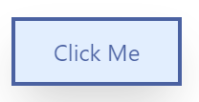After hover
Add button “Click Here” and design it as shown in image. Add hover effect and button will be displayed as shown in below image. Also, add transition and add animation of your choice.
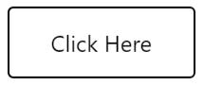After hover
<head>
<script src="https://cdn.tailwindcss.com"></script>
</head>
<body>
<a class="hover:animate-pulse my-11 mx-4 inline-block border-4 border-blue-900 text-blue-900 px-10 py-4 hover:bg-blue-100 text-2xl hover:shadow-2xl " href="#" >Click Me</a>

<button class="hover:animate-bounce px-10 py-4 bg-black text-white my-11 mx-4 text-2xl hover:text-black hover:bg-white hover:border-2 hover:border-black rounded-md transition-all duration-1000 hover:px-11 hover:py-5">Click Here</button>

</body>

Example
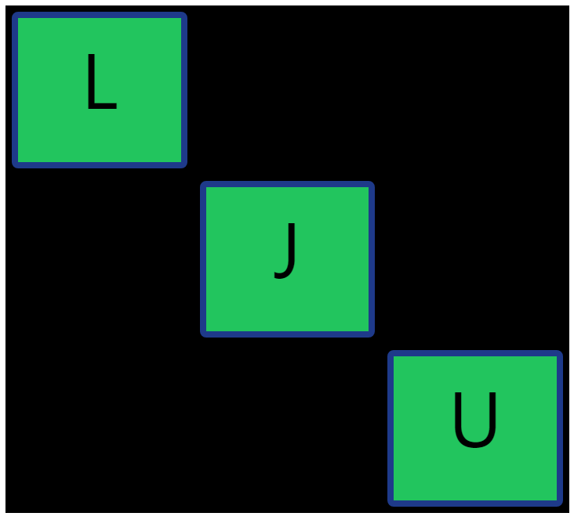
<div class="grid justify-items-auto grid-cols-3 bg-black m-4">
<div class="m-2 flex bg-green-500 rounded-lg border-8 border-blue-900 h-[200px] text-[100px] justify-center">L</div>
<div></div>
<div ></div>
<div ></div>
<div class="m-2 flex bg-green-500 border-8 border-blue-900 rounded-lg h-[200px] text-[100px] justify-center">J</div>
<div></div>
<div ></div>
<div ></div>
<div class="m-2 flex bg-green-500 border-8 border-blue-900 rounded-lg h-[200px] text-[100px] justify-center">U</div>
</div>

Example
Design product grids as shown in below image.
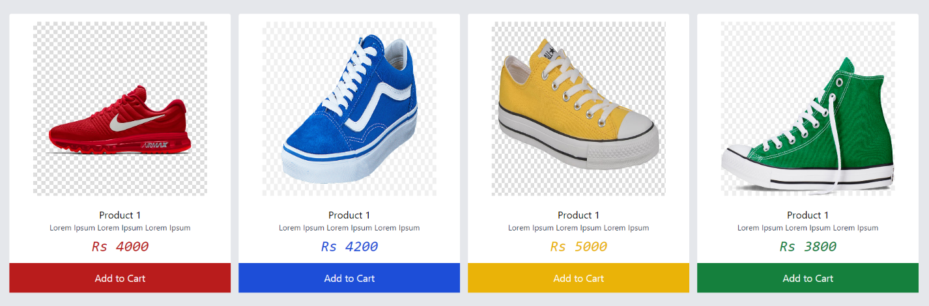

<head>
<script src="https://cdn.tailwindcss.com"></script>
</head>
<body>
<div class="grid grid-cols-4 gap-4 m-2 bg-gray-200 p-8">
<div class="rounded hover:shadow-2xl hover:shadow-black bg-white">
<img src="t2.jpg" class="w-96 h-96 p-4 mx-auto">
<div class="p-2">
<h2 class="text-xl text-center">Product 1</h2>
<p class="text-center text-gray-700">Lorem Ipsum Lorem Ipsum Lorem Ipsum</p>
<p class="text-red-700 text-center text-3xl italic font-mono p-2">Rs 4000</p>
</div>
<div class="block bg-red-700 p-4"><a href="#" class="text-white text-xl block text-center">Add to Cart</a></div>
</div>

<div class="rounded hover:shadow-2xl hover:shadow-black bg-white">
<img src="t3.png" class="w-96 h-96 p-4 mx-auto">
<div class="p-2">
<h2 class="text-xl text-center">Product 1</h2>
<p class="text-center text-gray-700">Lorem Ipsum Lorem Ipsum Lorem Ipsum</p>
<p class="text-blue-700 text-center text-3xl italic font-mono p-2">Rs 4200</p>
</div>
<div class="block bg-blue-700 p-4"><a href="#" class="text-white text-xl block text-center">Add to Cart</a></div>
</div>

<div class="rounded hover:shadow-2xl hover:shadow-black bg-white">
<img src="t1.jpg" class="w-96 h-96 p-4 mx-auto">
<div class="p-2">
<h2 class="text-xl text-center">Product 1</h2>
<p class="text-center text-gray-700">Lorem Ipsum Lorem Ipsum Lorem Ipsum</p>
<p class="text-yellow-500 text-center text-3xl italic font-mono p-2">Rs 5000</p>
</div>
<div class="block bg-yellow-500 p-4"><a href="#" class="text-white text-xl block text-center">Add to Cart</a></div>
</div>

<div class="rounded hover:shadow-2xl hover:shadow-black bg-white">
<img src="t4.png" class="w-96 h-96 p-4 mx-auto">
<div class="p-2">
<h2 class="text-xl text-center">Product 1</h2>
<p class="text-center text-gray-700">Lorem Ipsum Lorem Ipsum Lorem Ipsum</p>
<p class="text-green-700 text-center text-3xl italic font-mono p-2">Rs 3800</p>
</div>
<div class="block bg-green-700 p-4"><a href="#" class="text-white text-xl block text-center">Add to Cart</a></div>
</div>
</div>
</body>

Example
Design navbar as shown in below image using tailwind classes. Also add animated utility to make an element gently fade in and out

<nav class="bg-black p-4 m-8">
<div class="mx-auto flex justify-between">
<!-- Logo on the left -->
<div class="text-red-700 text-xl">
<a href="#">Logo</a>
</div>
<!-- Links in the middle -->
<div>
<a href="#" class="font-extrabold text-white p-2 hover:text-red-800">Home</a>
<a href="#" class="font-extrabold text-white p-2 hover:text-red-800">About</a>
<a href="#" class="font-extrabold text-white p-2 hover:text-red-800">Services</a>
<a href="#" class="font-extrabold text-white p-2 hover:text-red-800">Contact</a>
</div>
<!-- Login link on the right -->
<div>
<a href="#" class="animate-pulse text-red-900 font-extrabold hover:text-red-900 border-2 p-2 bg-white rounded-xl border-red-900">Login</a>
</div>
</div>
</nav>

